|  |  |  |  |  |  |  |  |  |
| --- | --- | --- | --- | --- | --- | --- | --- | --- |
| Forecast Values | |  |  |  | Compiler Engine Information | | |  |
|  |  |  |  |  |  |  |  |  |
| Stand ID: | | 1082523 | | | GYPSY Model: | | 2009-May-21 | |
| Stand Type: | | Natural |  |  | Application: | | 20100713p | |
| Stand Age: | | 45 | years |  | COM DLL: | | 20100329b35 | |
| Spatial: | | NO |  |  |  |  |  |  |
| BA adjusted: | | YES |  |  |  |  |  |  |
|  |  |  |  |  |  |  |  |  |
| Input Data | |  |  |  |  |  |  |  |
|  |  |  |  |  |  |  |  |  |
| Species | | totage | topht | den | ps | ba | utilization | |
| AW |  | 45.0 | 4.57 | 106 |  | 1.26 | 13/7/30 | |
| SB |  |  |  |  |  |  | 15/10/30 | |
| SW |  | 37.0 | 4.57 | 169 |  | 2.02 | 13/7/30 | |
| PL |  | 31.0 | 4.57 | 786 |  | 9.37 | 13/7/30 | |
|  |  |  |  |  |  |  |  |  |
| Calculated Attributes | | |  |  |  |  |  |  |
|  |  |  |  |  |  |  |  |  |
| Species | | bhage | y2bh | si_bh | si_t | n0 | sdf | psi |
| AW |  | 32.2 | 12.8 | 6.1 | 5.0 | 106 | 106 |  |
| SB |  |  |  |  |  |  |  |  |
| SW |  | 21.8 | 15.2 | 8.8 | 6.6 | 169 | 169 |  |
| PL |  | 18.5 | 12.5 | 9.3 | 7.6 | 801 | 750 |  |

Tesera Gypsy

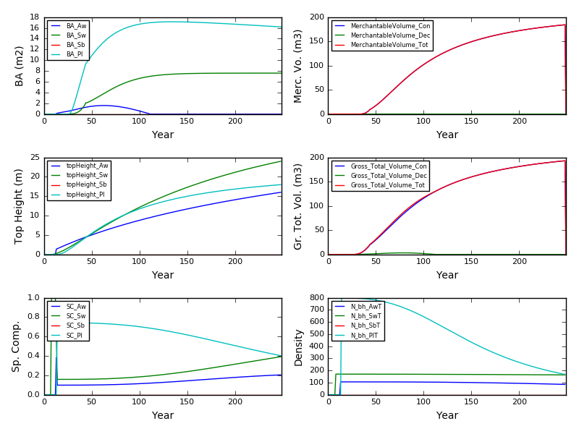

Excel Gypsy

